**Nour Nahar Priyaly**

**ID- 22-46884-1**

**4.**

1. Select ename, job, deptno from emp WHERE job='CLERK';

2. Select ename, sal, comm FROM emp WHERE sal<=comm;

3. SELECT ename, sal FROM emp WHERE sal BETWEEN 1000 AND 1500;

4. SELECT empno, ename, sal, mgr FROM emp WHERE mgr IN (7902, 7566, 7788);

5. SELECT ename FROM emp WHERE ename LIKE '_A%';

6. SELECT ename, mgr FROM emp WHERE mgr IS NULL;

7. SELECT empno, ename, job, sal FROM emp WHERE sal>=1100 AND job='CLERK';

8. SELECT empno, ename, job, sal FROM emp WHERE sal>=1100 OR job='CLERK';

9. SELECT ename, job FROM emp WHERE job NOT IN ('CLERK','MANAGER','ANALYST');

10. SELECT ename, job, sal FROM emp WHERE (job='SALESMAN' OR job='PRESIDENT') AND sal>1500;

11. SELECT ename, job, sal FROM emp WHERE job='SALESMAN' OR job='PRESIDENT' AND sal>1500;

12. SELECT ename, job, deptno, hiredate FROM emp ORDER BY hiredate;

13. SELECT ename, job, deptno, hiredate FROM emp ORDER BY hiredate DESC;

14. SELECT edpno, ename, sal*12 annsal FROM emp ORDER BY annsal;

15. SELECT ename, deptno, sal FROM emp ORDER BY deptno, sal DESC;

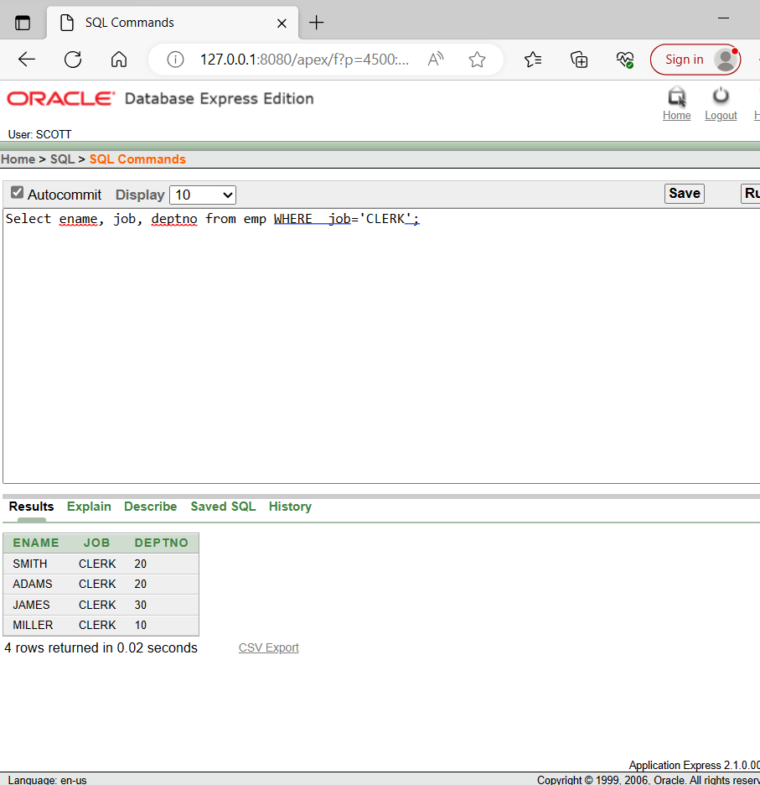

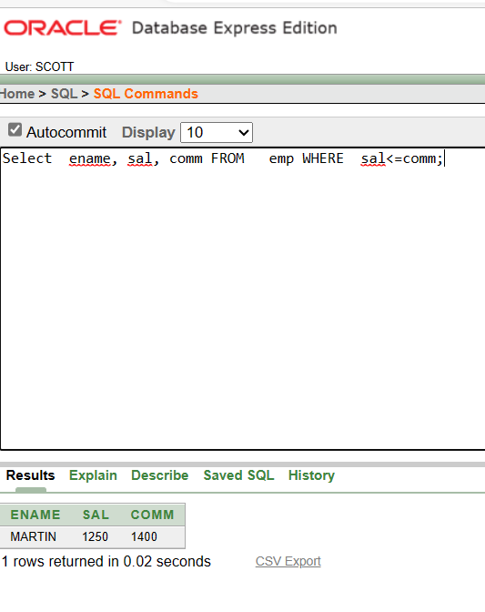

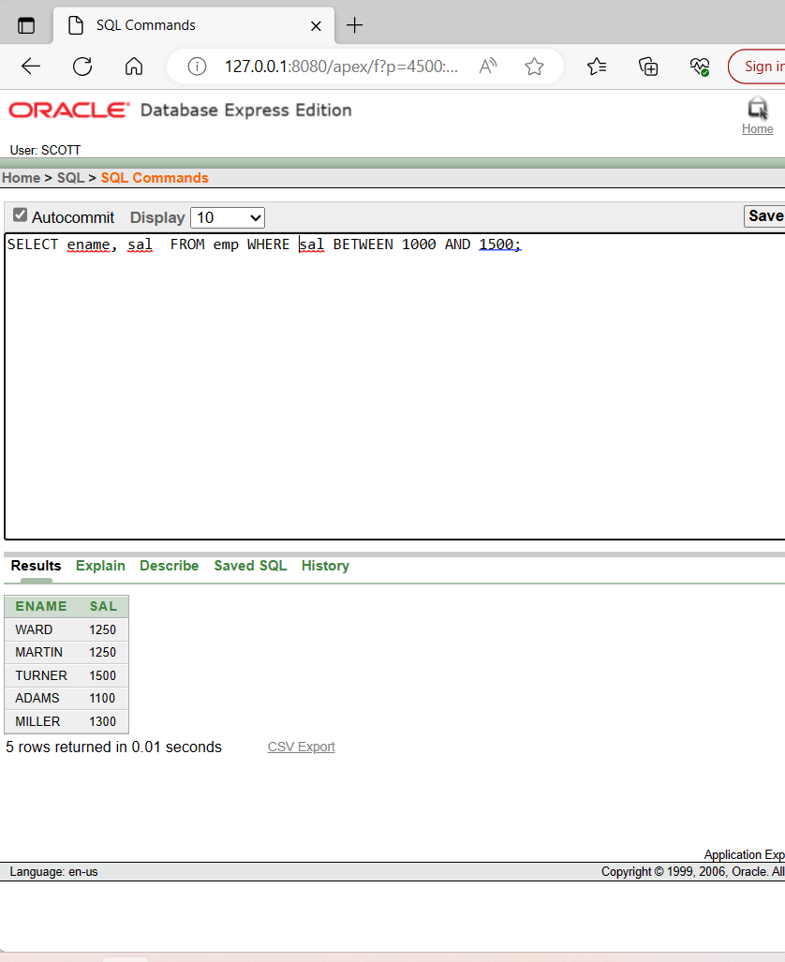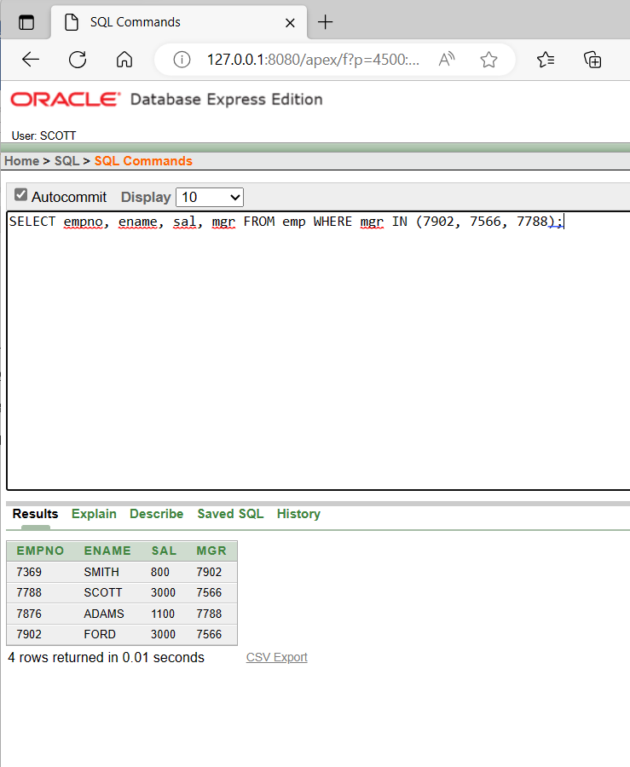

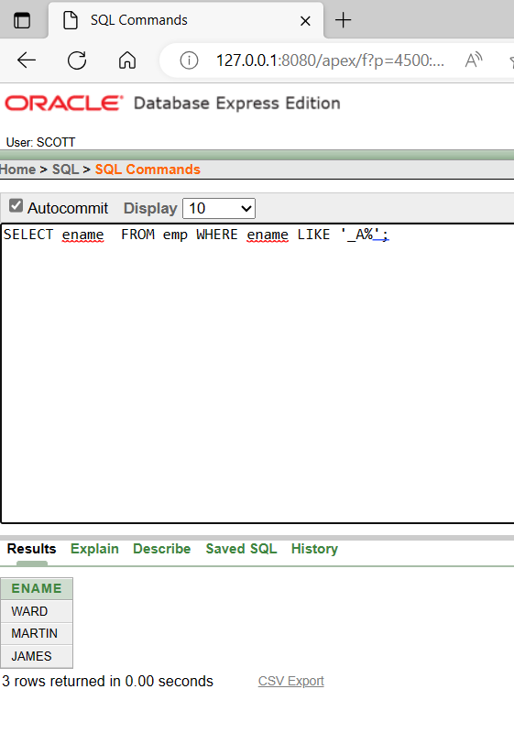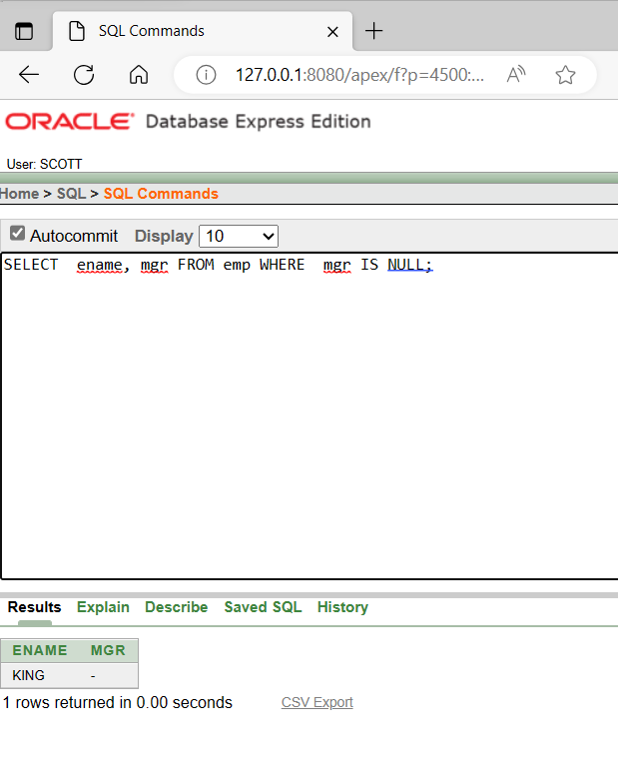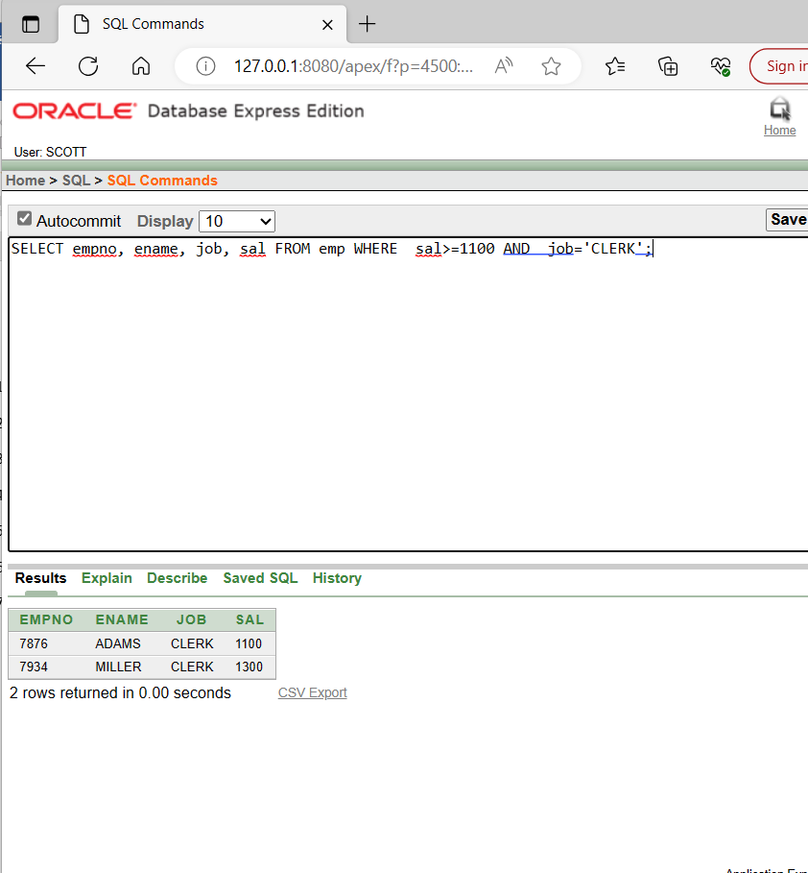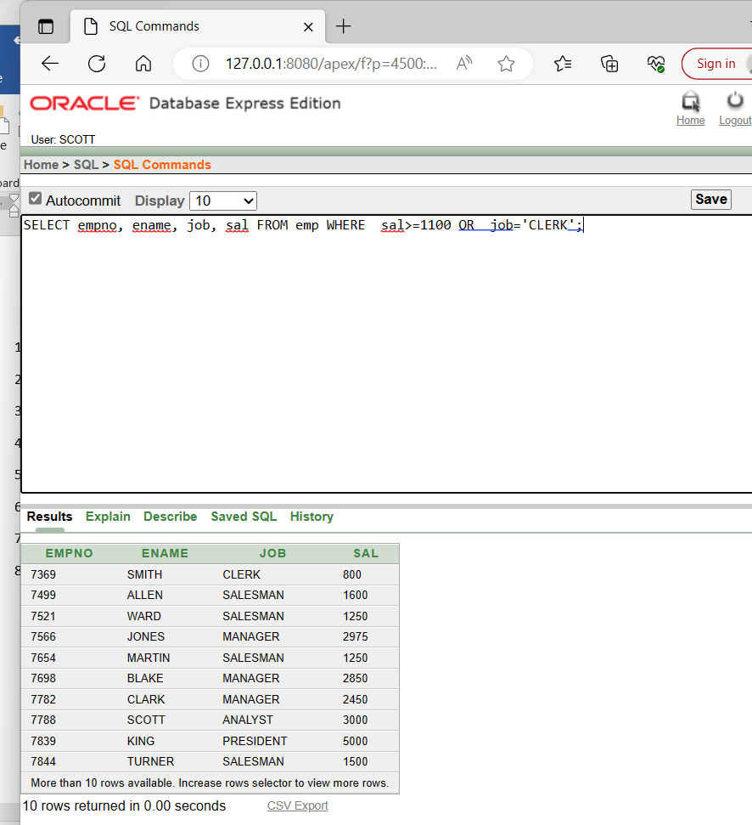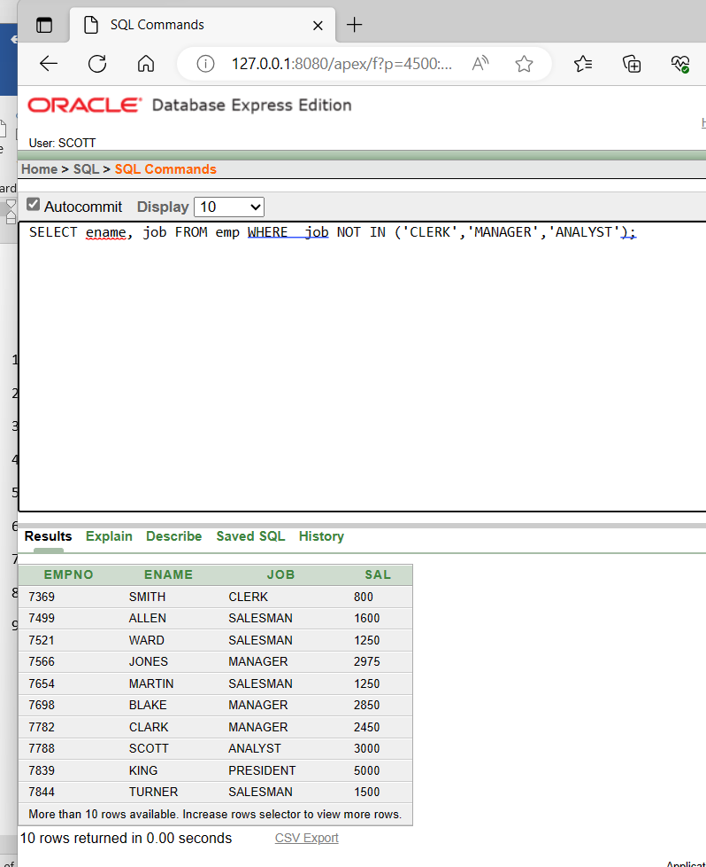

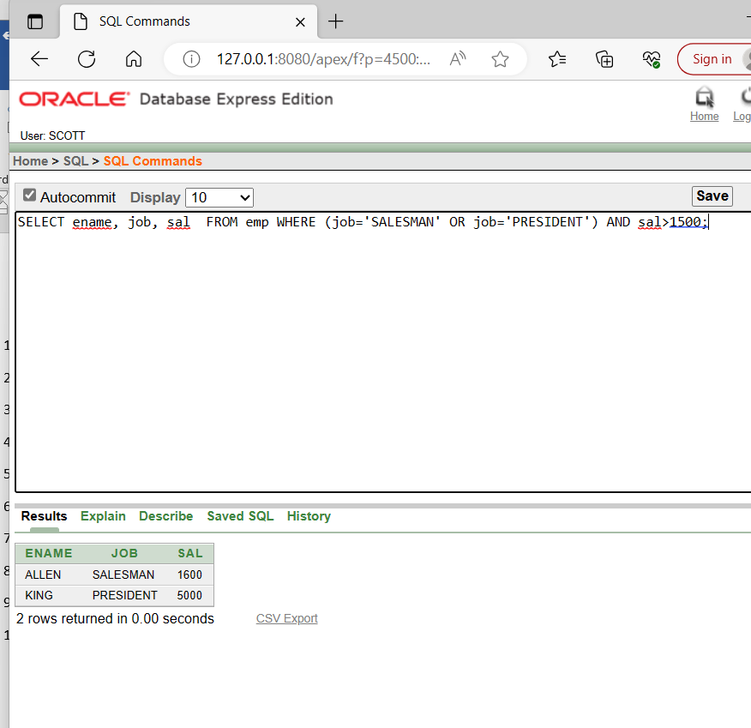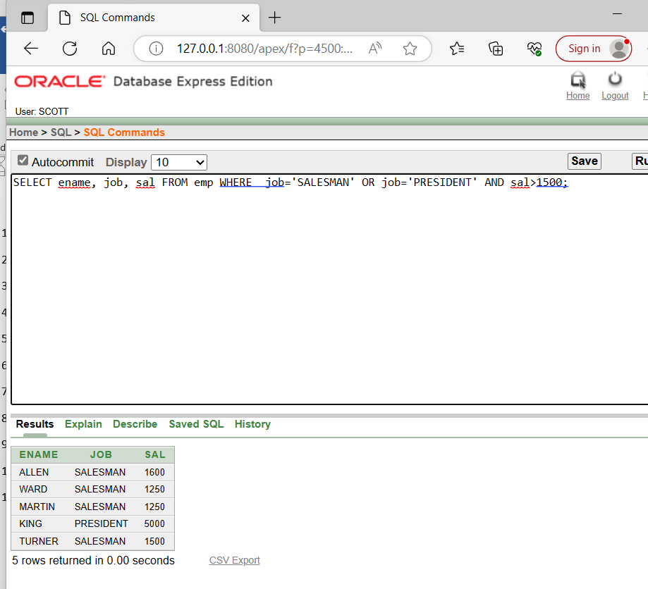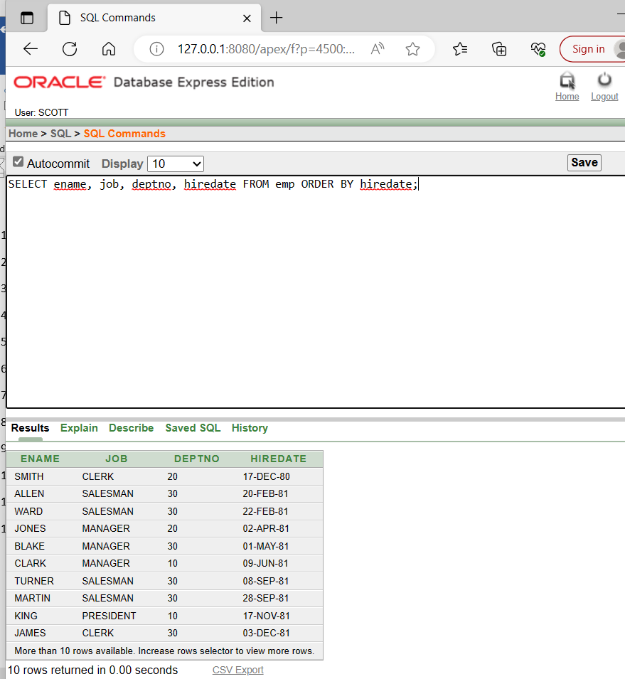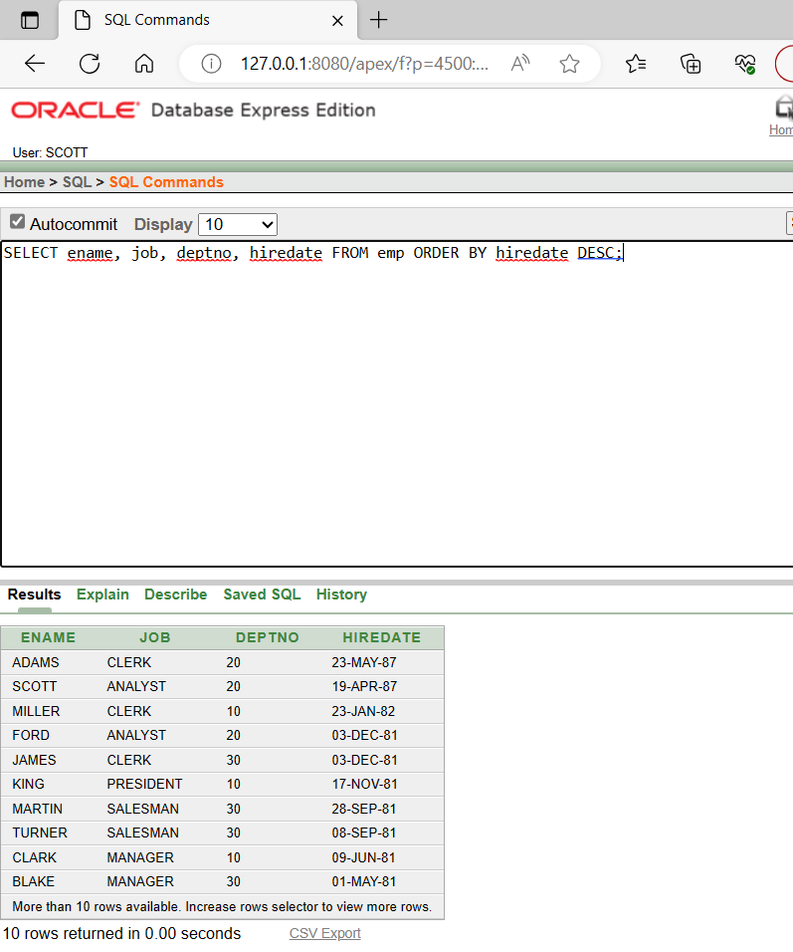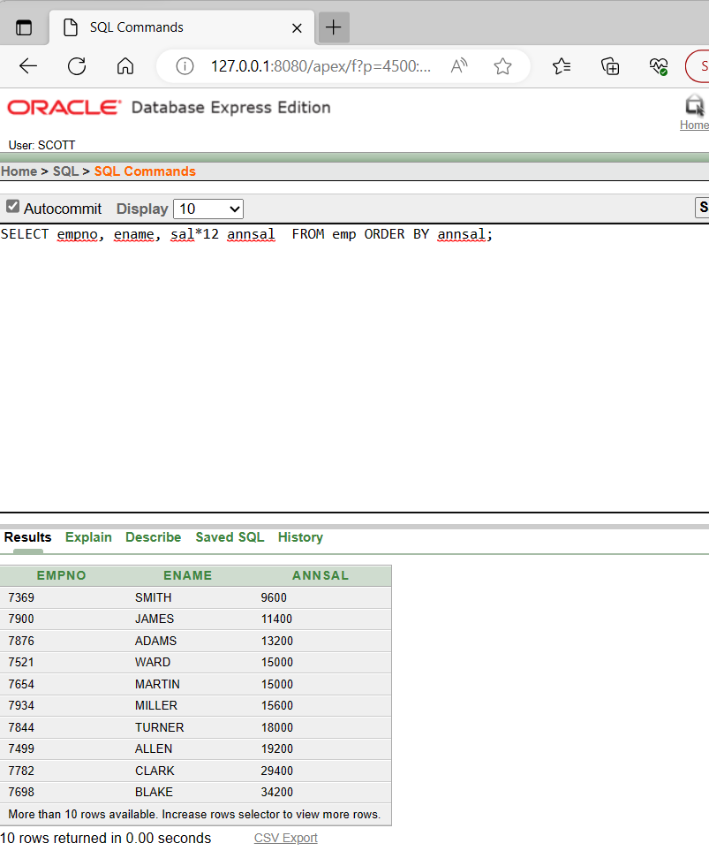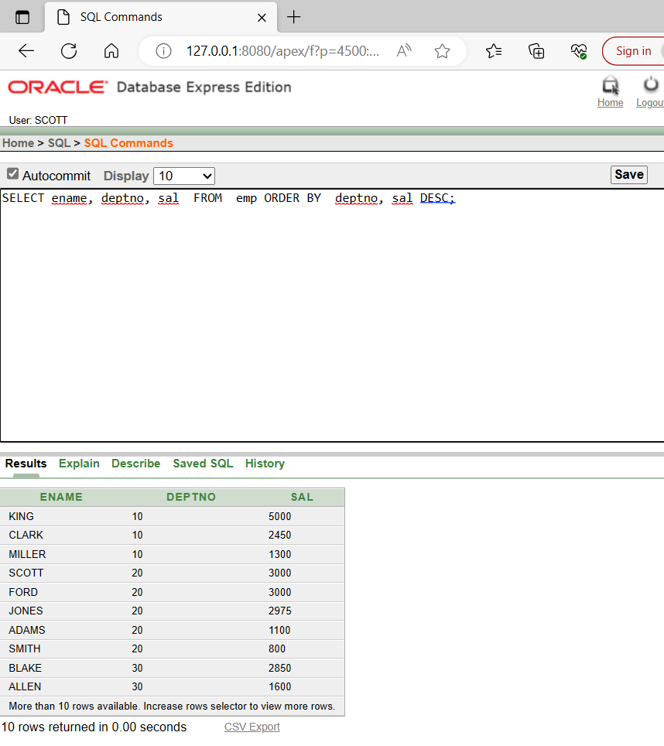

**6**

1. SELECT empno, ename, deptno FROM emp WHERE LOVER (ename) = 'blake';
2. SELECT ename, CONCAT (ename, job), LENGTH (ename), INSTR(ename, 'A') FROM emp WHERE SUBSTR(job,1,5) = 'SALES';
3. SELECT ROUND(45.923,2), ROUND(45.923,0), ROUND(45.923,-1) FROM DUAL;
4. SELECT TRUNC(45.923,2), TRUNC(45.923), TRUNC(45.923,-1) FROM DUAL;
5. SELECT ename, sal, comm, MOD(sal, comm) FROM emp WHERE job = 'SALESMAN';
6. SELECT ename, (SYSDATE-hiredate) /7 WEEKS FROM emp WHERE deptno = 10;
7. SELECT ename, TO_CHAR(hiredate,'fmDD Month YYYY') HIRDATE FROM emp
8. SELECT TO_CHAR(sal,'$99,999') SALARY FROM emp WHERE ename = 'SCOTT';
9. SELECT ename, sal, comm, (sal*12)+NVL(comm,0) FROM emp;
10. SELECT job, sal, DECODE(job, 'ANALYST', SAL*1.1, 'CLERK', SAL*1.15, 'MANAGER', SAL*1.20, SAL) REVISED_SALARY FROM emp;
11. SELECT ename, NVL(TO_CHAR(mgr),'No Manager') FROM emp WHERE mgr IS NULL;

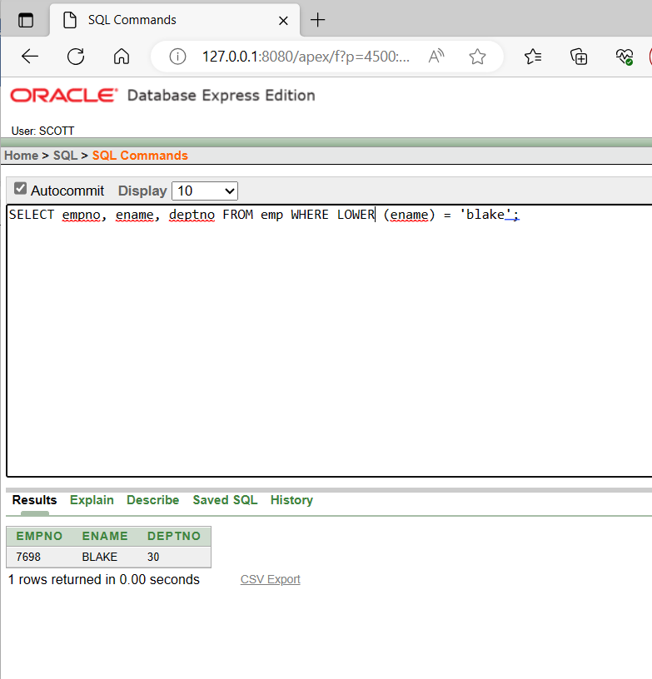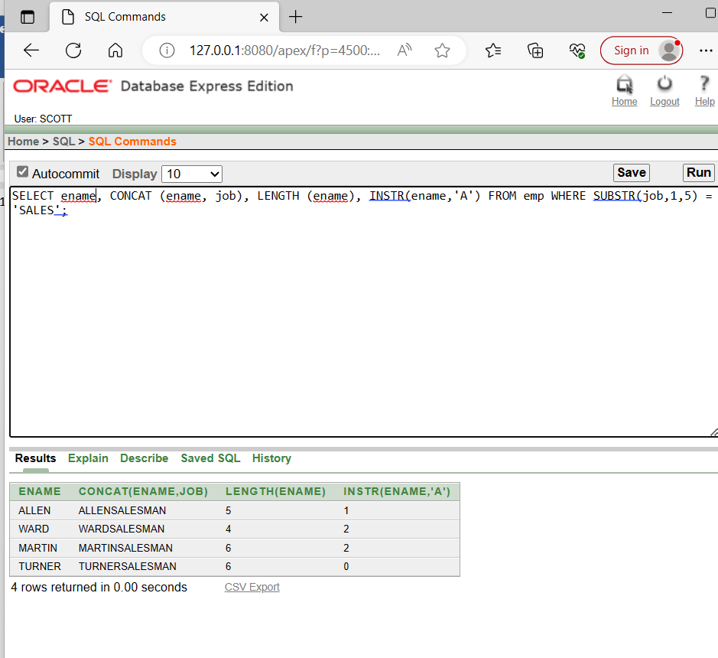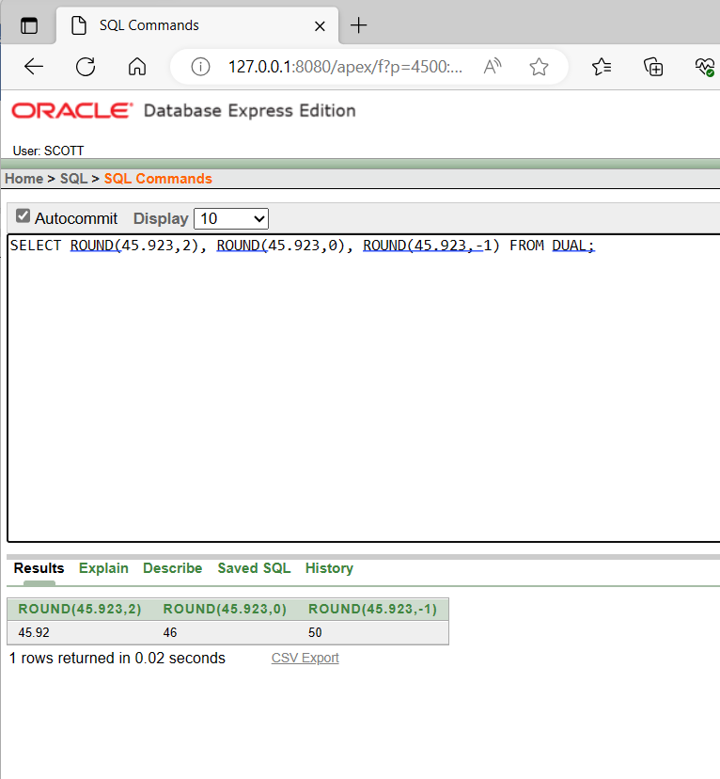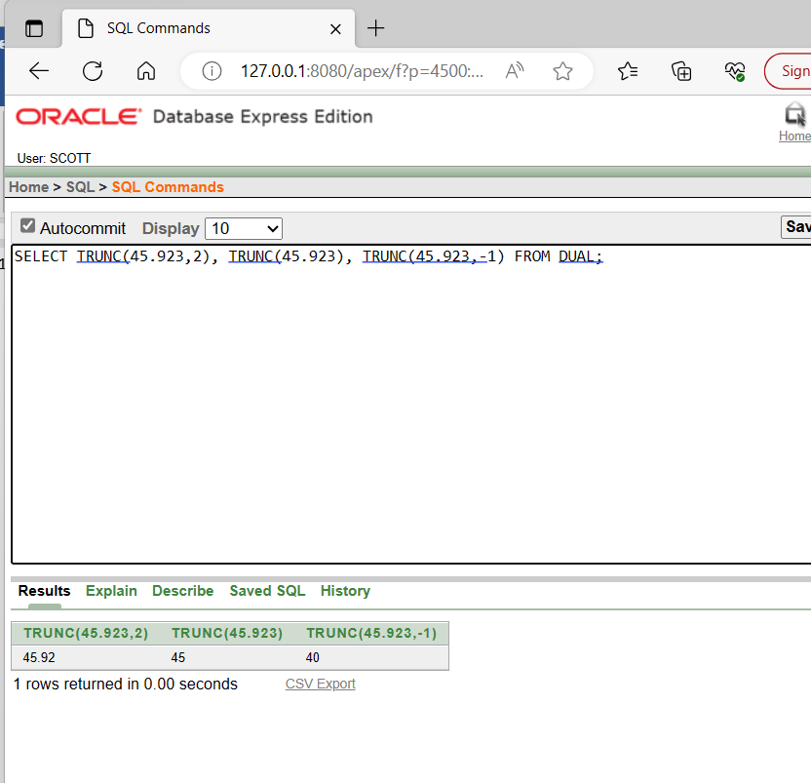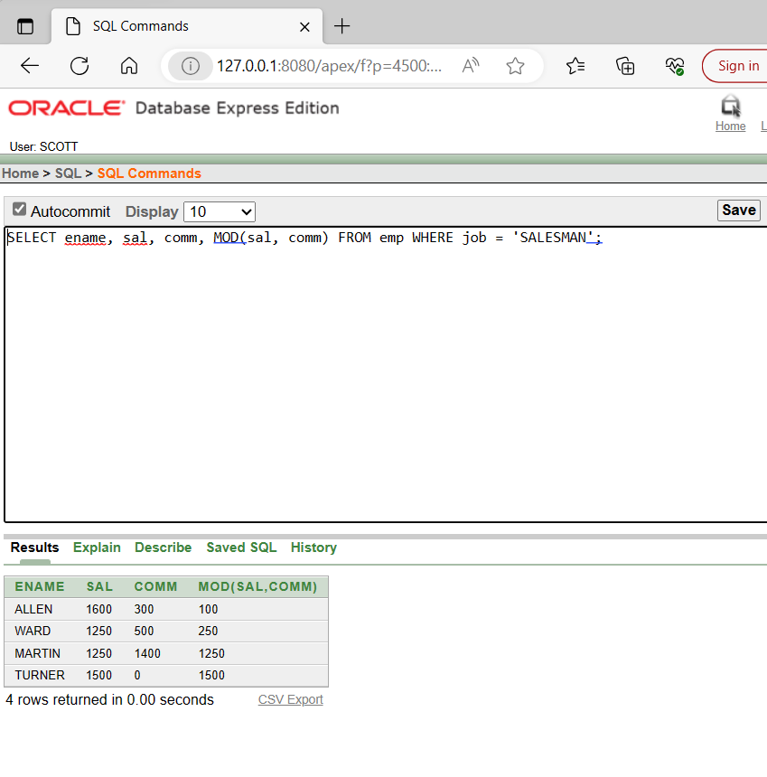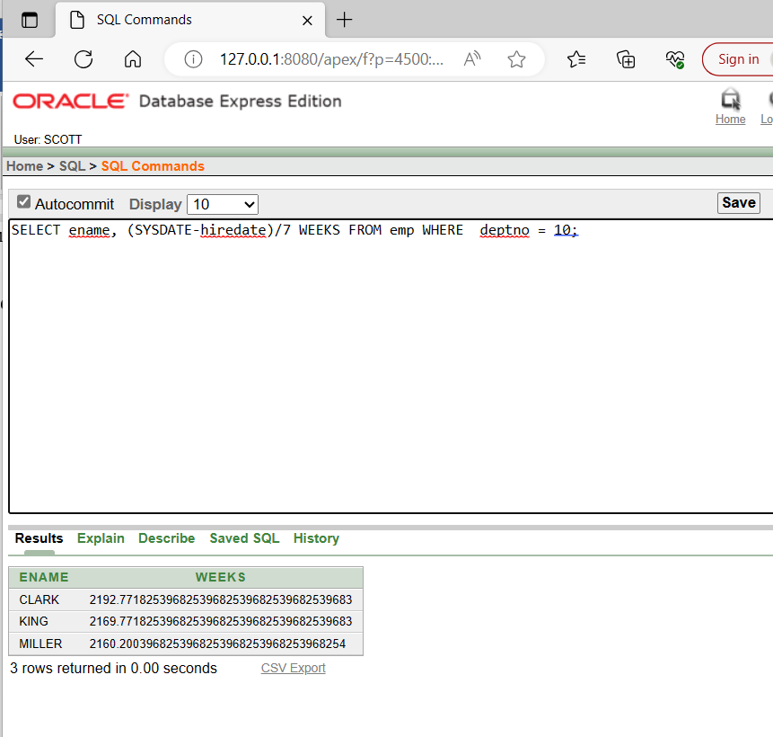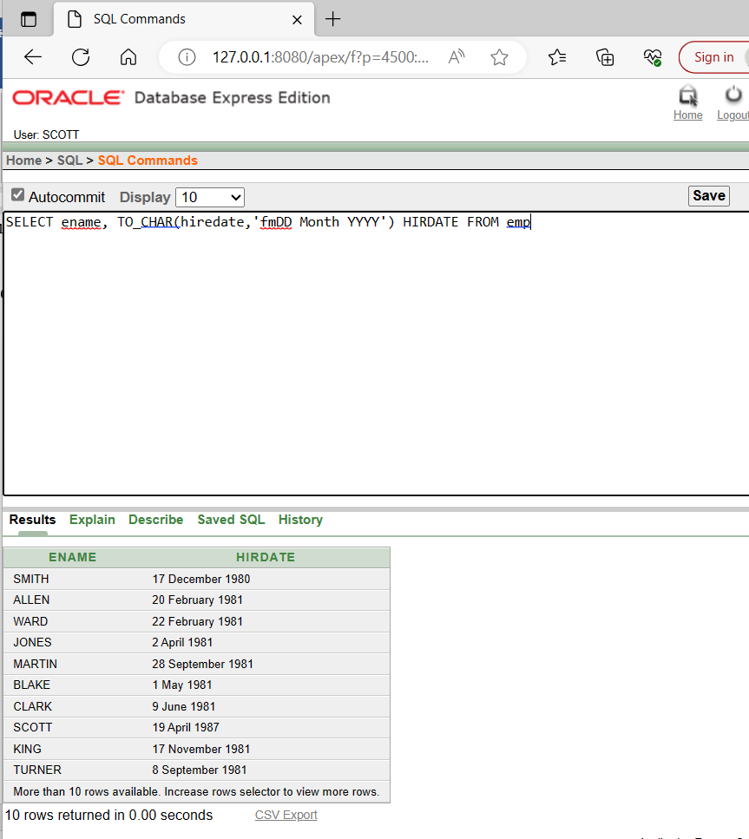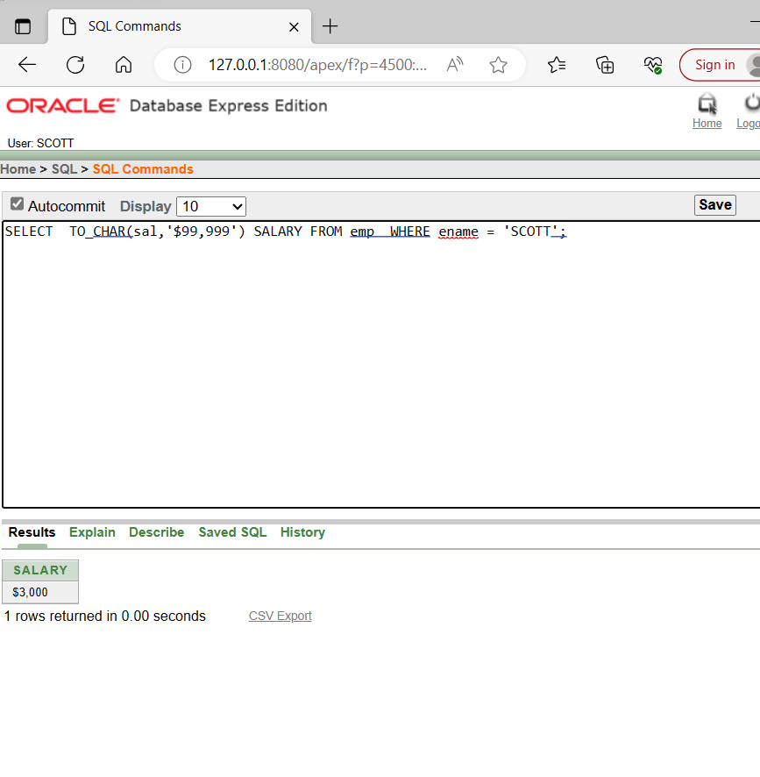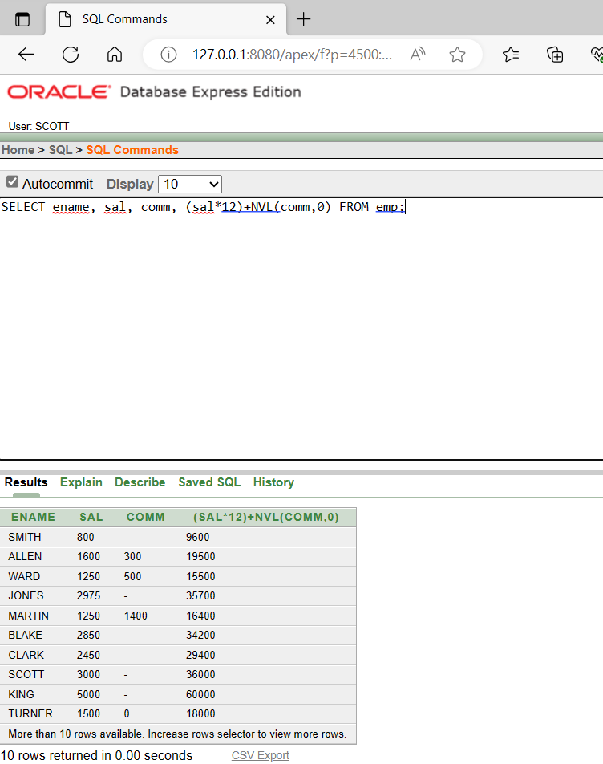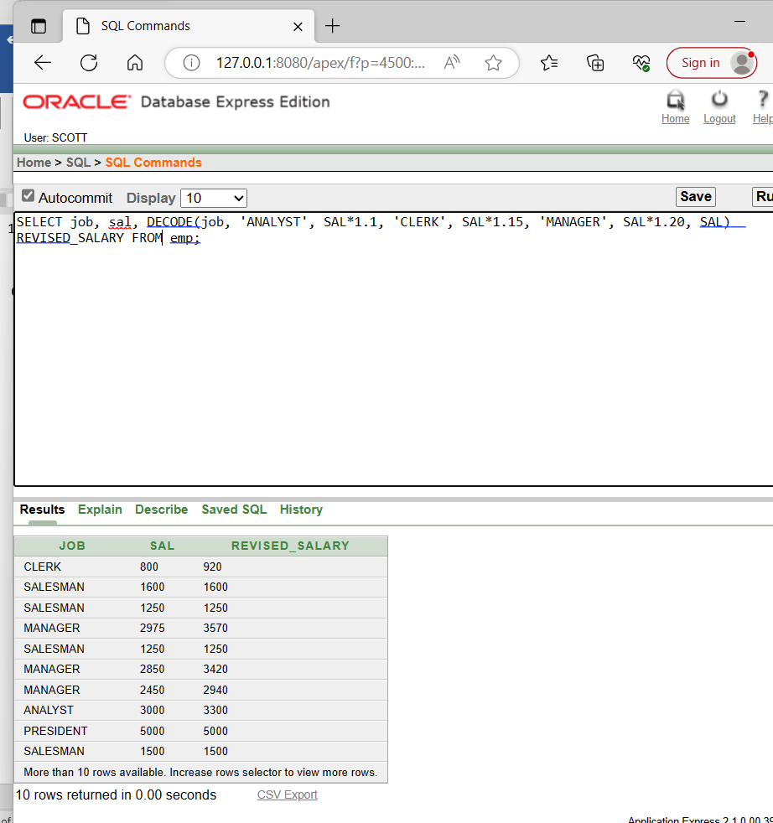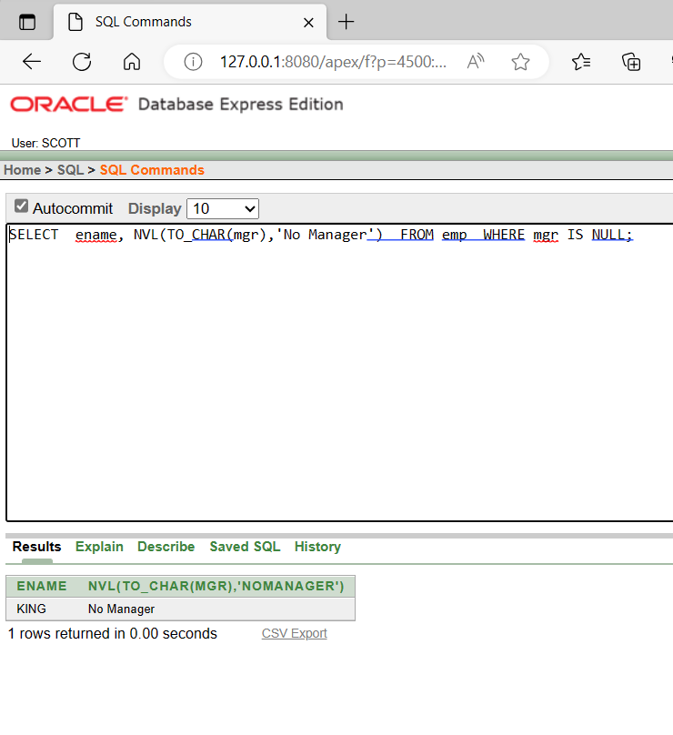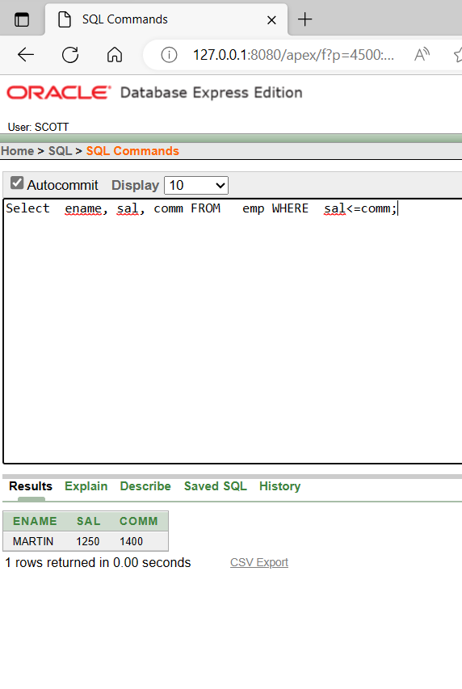

**8.**

1. SELECT AVG(sal), MAX(sal), MIN(sal), SUM(sal) FROM emp WHERE job LIKE 'SALES%';
2. SELECT MIN(hiredate), MAX(hiredate) FROM emp*;*
3. SELECT COUNT(*) FROM emp WHERE deptno = 30;
4. SELECT COUNT(comm) FROM emp WHERE deptno = 30;
5. SELECT AVG(comm) FROM emp;
6. SELECT AVG(NVL(comm,0)) FROM emp;
7. SELECT deptno, AVG(sal) FROM emp GROUP BY deptno;
8. SELECT AVG(sal) FROM emp GROUP BY deptno;
9. SELECT deptno, job, sum(sal) FROM emp GROUP BY deptno, job;
10. SELECT deptno, max(sal) FROM emp GROUP BY deptno HAVING max(sal)>2900;
11. SELECT job, SUM(sal) PAYROLL FROM emp WHERE job NOT LIKE 'SALES%' GROUP BY job HAVING SUM(sal)>5000 ORDER BY SUM(sal);
12. SELECT max(avg(sal)) FROM emp GROUP BY deptno;

